1. Creating and Renaming Files/Directories

1.1 Create a directory named test_dir using mkdir.

Command - mkdir test_dir

Explanation - the command “mkdir” is use to make a new directory in current location.

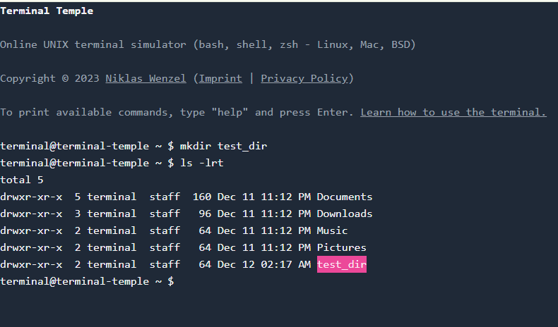

1.2 Inside test_dir, create an empty file called example.txt.

Command - touch example.txt

Explanation - the command “touch” is use to make new file in current location.

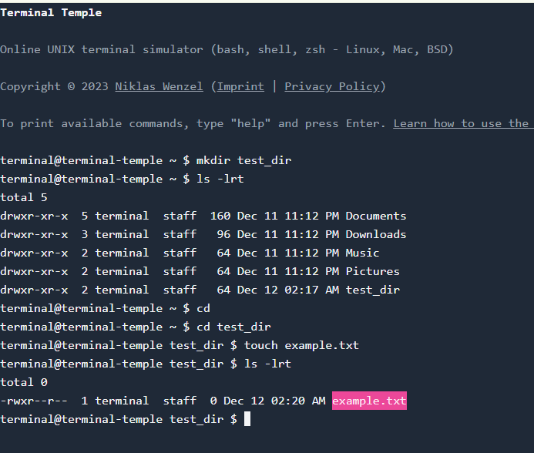

1.4 Rename example.txt to renamed_example.txt using mv

Command - mv example.txt renamed_example.txt

Explanation - the command “mv” is use to rename and moving files or directories from one location to other.

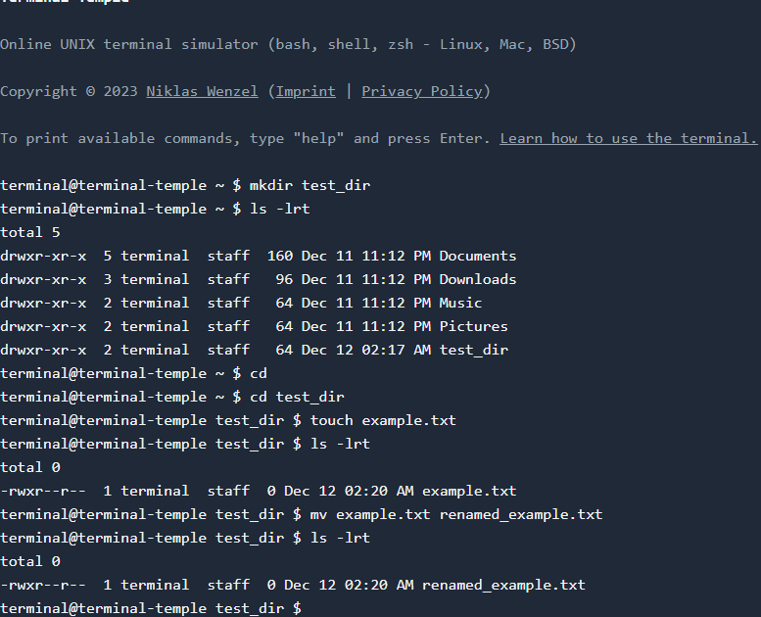

2. Viewing File Contents

2.1 Use cat to display the contents of /etc/passwd.

Command - cat /etc/passwd

Explanation - the command “cat” most basic use to view the entire text of a single file.

2.2 Display only the first 5 lines of /etc/passwd using head.

Command - head -n 5 /etc/passwd

Explanation - the command “head” by default, it display the first 10 lines of the specified input. And command “head -n 5” use to display first 5 lines of the specified file.

2.3 Display only the last 5 lines of /etc/passwd using tail.

Command - tail -n 5 /etc/passwd

Explanation - the command “tail” by default, it display the last 10 lines of the specified input. And command “head -n 5” use to display last 5 lines of the specified file.

3.Searching for Patterns

3.1 Use grep to find all lines containing the word "root" in /etc/passwd.

Command - grep “root” /etc/passwd

Explanation - the command “grep” is used to search for specific text patterns, words, or expressions within files or output streams. And command “grep “root” ” is use to search for the specific string "root" within a file or from command output

4. Zipping and Unzipping

4.1 Compress the test_dir directory into a file named test_dir.zip using zip.

Command - zip -r test_dir.zip test_dir

Explanation - the command “zip” is use to compress only the file one by one. And command “zip -r” compresses the entire directory, including all sub-directories and file inside it.

4.2 Unzip test_dir.zip into a new directory named unzipped_dir.

Command - unzip test_dir.zip -d unzipped_dir

Explanation - the command “unzip” use to unzip the zip file or directories.

Breakdown of the Command

unzip: The primary utility used to extract files and directories from ZIP archives.

test_dir.zip: The source ZIP file you want to extract.

-d: An optional flag that specifies the destination directory.

unzipped_dir: The name (or path) of the folder where the extracted contents will be placed.

5. Downloading Files

5.1 Use wget to download a file from a URL (e.g., <https://example.com/sample.txt>).

Command - wget <https://example.com/sample.txt>

Explanation - the command “wget” stand for Web Get and is uses to download a file from HTTP, HTTPS, and FTP URLs.

6. Changing Permissions

6.1 Create a file named secure.txt and change its permissions to read-only for everyone using chmod.

Command - touch secure.txt --(file created)

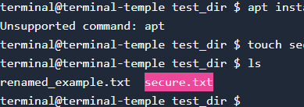

Command for change permission - chmod 444 secure.txt or chmod a=r secure.txt

Explanation - the command “chmod” is used to manage file system access permissions for files and directories. It allows users to control who can read (r), write (w), and execute (x) specific items.

The command “chmod444” use to give read-only permission. In Linux file permission notation, 444 is represented as r--r--r--

7. Working with Environment Variables

7.1 Use export to set a new environment variable called MY_VAR with the value "Hello, Linux!".

Command - export MY_VAR=”Hello, Linux!”

Explanation - the command export MY_VAR="Hello, Linux!" is used to create or update an environment variable that is accessible to the current shell and any child processes it launches.

**Submission Guidelines -:** Attach Screenshots or command along with explanation and submit in doc(google doc or microsoft doc) format also attach github repo link